DAY 4

CSS

CSS Selectors

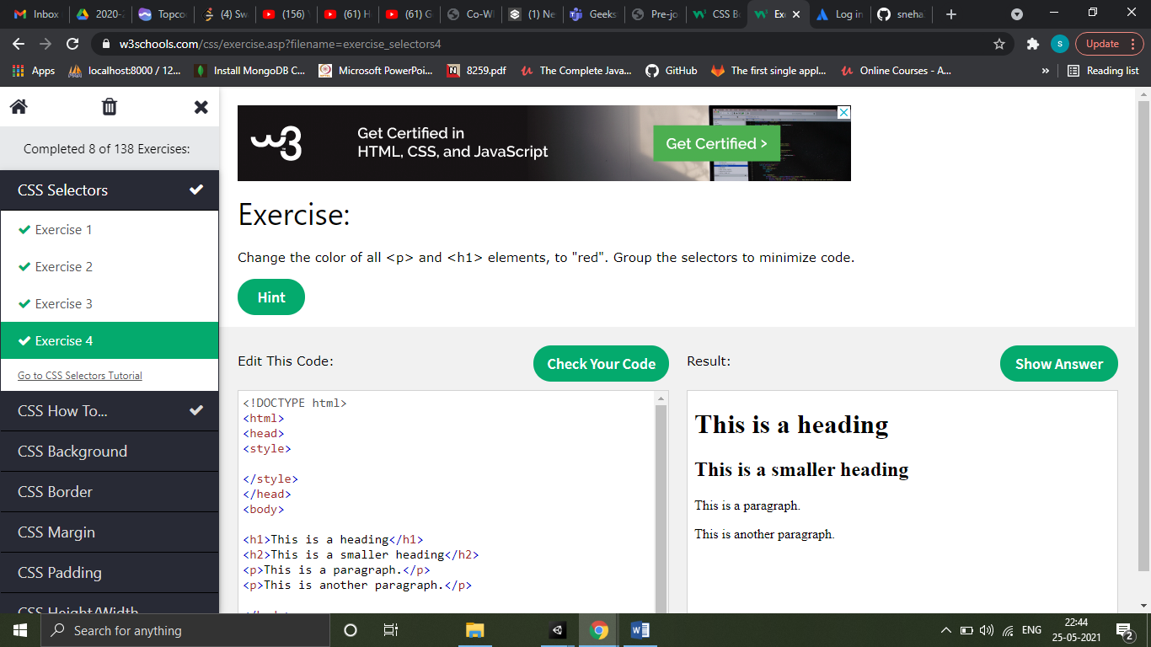

Cascading order

All the styles in a page will "cascade" into a new "virtual" style sheet by the following rules, where number one has the highest priority:

1. Inline style (inside an HTML element)
2. External and internal style sheets (in the head section)
3. Browser default

So, an inline style has the highest priority, and will override external and internal styles and browser defaults.

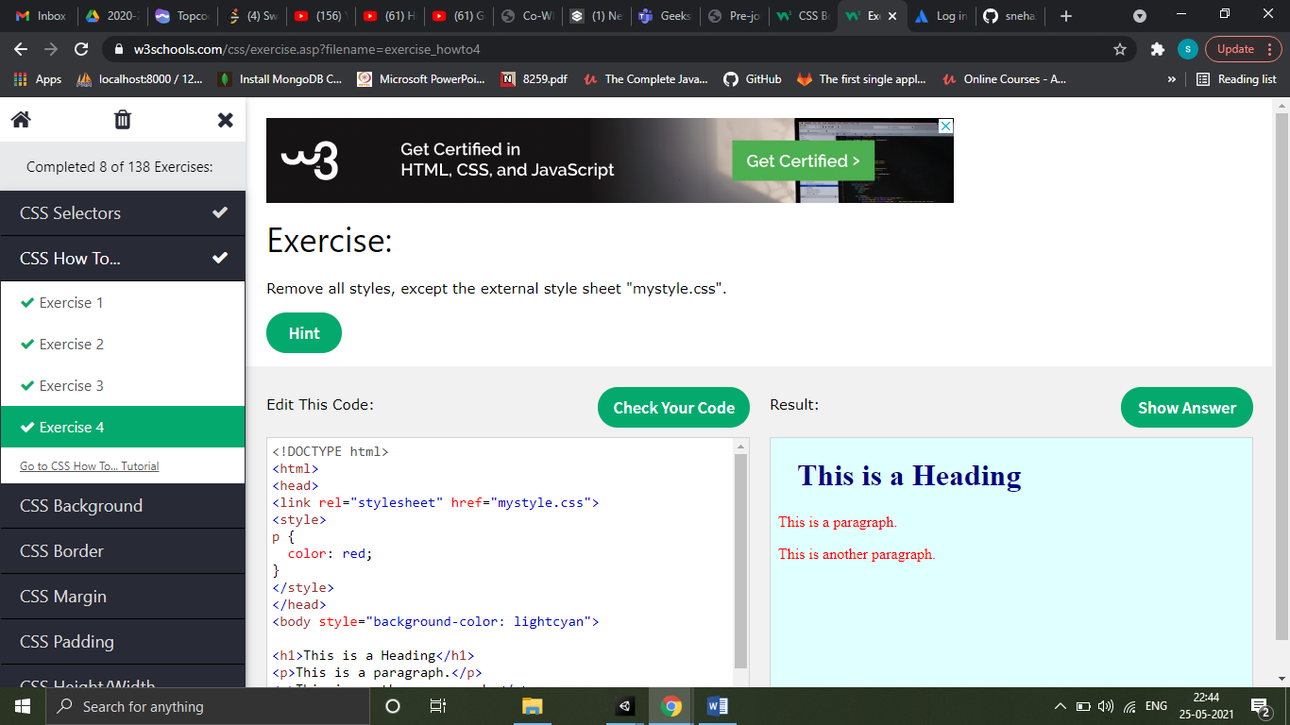

CSS Colors

In CSS, colors can also be specified using RGB values, HEX values, HSL values, RGBA values and HSLA values.

RGB => Red, Green, Blue

Hex => #rrggbb or #rgb

HSL => Hue, Saturation, Lightness

CSS Backgounds

All CSS background properties

|  |  |
| --- | --- |
| **Property** | **Description** |
| [background](https://www.w3schools.com/cssref/css3_pr_background.asp) | Sets all the background properties in one declaration |
| [background-attachment](https://www.w3schools.com/cssref/pr_background-attachment.asp) | Sets whether a background image is fixed or scrolls with the rest of the page |
| [background-clip](https://www.w3schools.com/cssref/css3_pr_background-clip.asp) | Specifies the painting area of the background |
| [background-color](https://www.w3schools.com/cssref/pr_background-color.asp) | Sets the background color of an element |
| [background-image](https://www.w3schools.com/cssref/pr_background-image.asp) | Sets the background image for an element |
| [background-origin](https://www.w3schools.com/cssref/css3_pr_background-origin.asp) | Specifies where the background image(s) is/are positioned |
| [background-position](https://www.w3schools.com/cssref/pr_background-position.asp) | Sets the starting position of a background image |
| [background-repeat](https://www.w3schools.com/cssref/pr_background-repeat.asp) | Sets how a background image will be repeated |
| [background-size](https://www.w3schools.com/cssref/css3_pr_background-size.asp) | Specifies the size of the background image(s) |

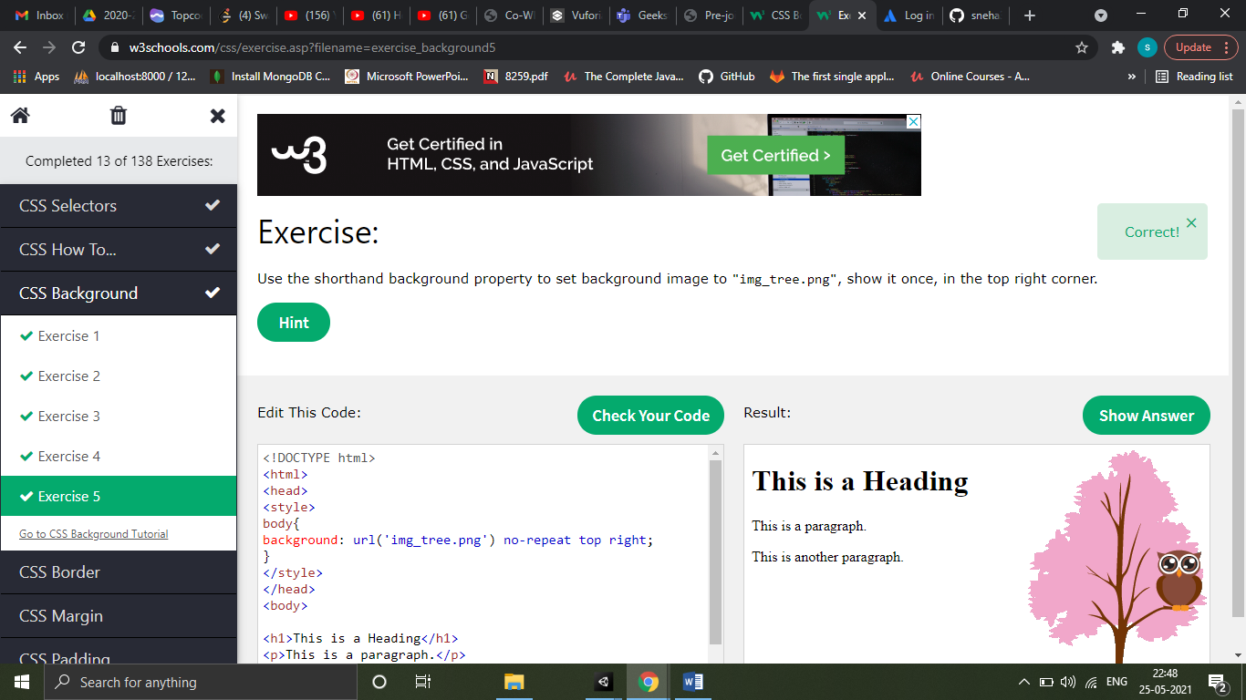

CSS Borders

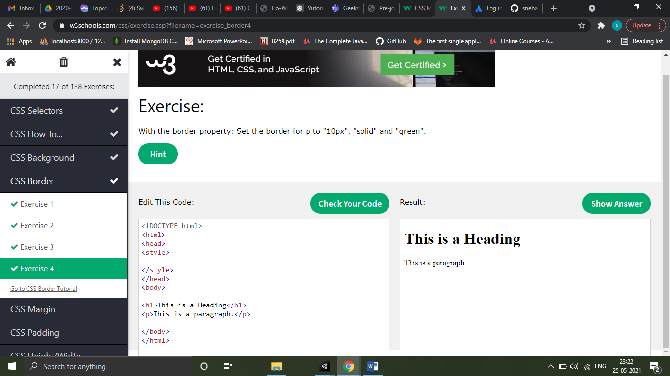

CSS Margins

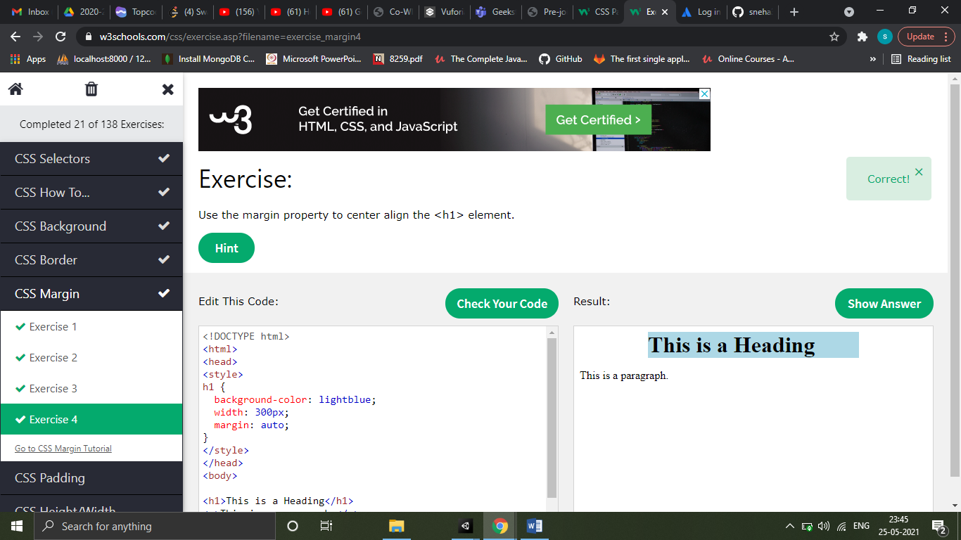

CSS Padding

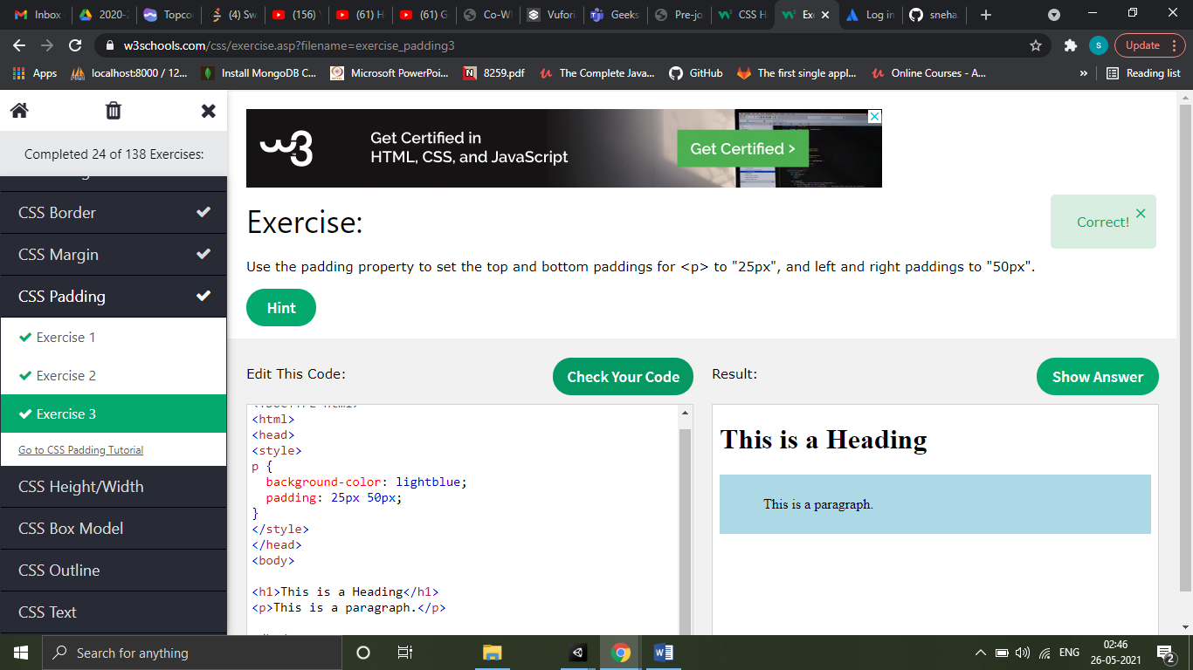

CSS Height/Width

The height and width properties may have the following values:

* auto - This is default. The browser calculates the height and width
* length - Defines the height/width in px, cm etc.
* % - Defines the height/width in percent of the containing block
* initial - Sets the height/width to its default value
* inherit - The height/width will be inherited from its parent value

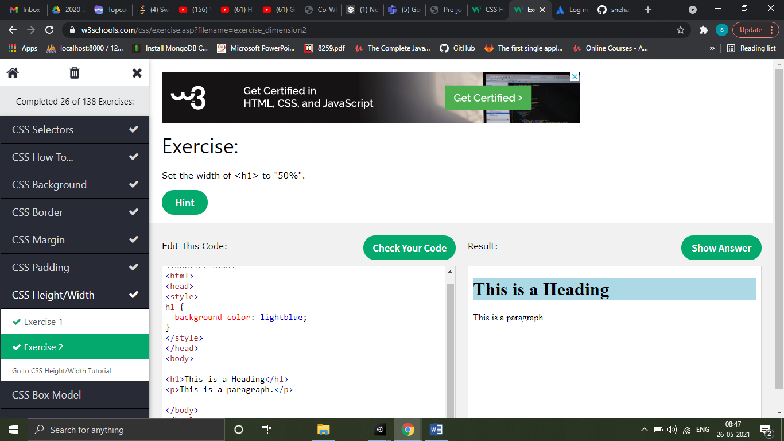

CSS Box Model

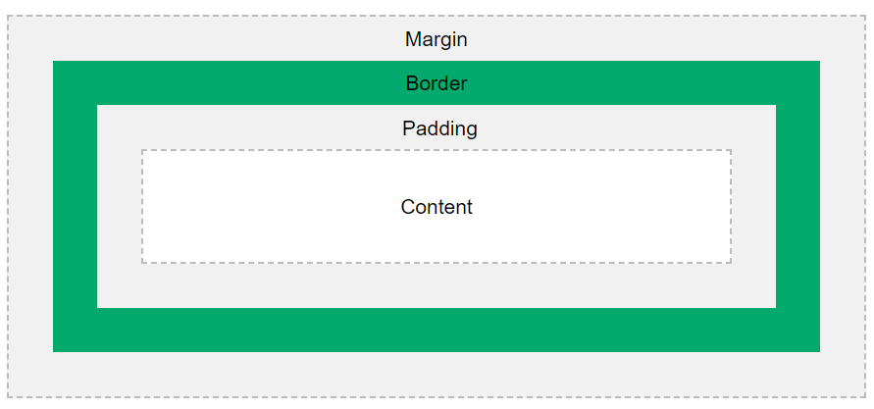

Explanation of the different parts:

* **Content** - The content of the box, where text and images appear
* **Padding** - Clears an area around the content. The padding is transparent
* **Border** - A border that goes around the padding and content
* **Margin** - Clears an area outside the border. The margin is transparent

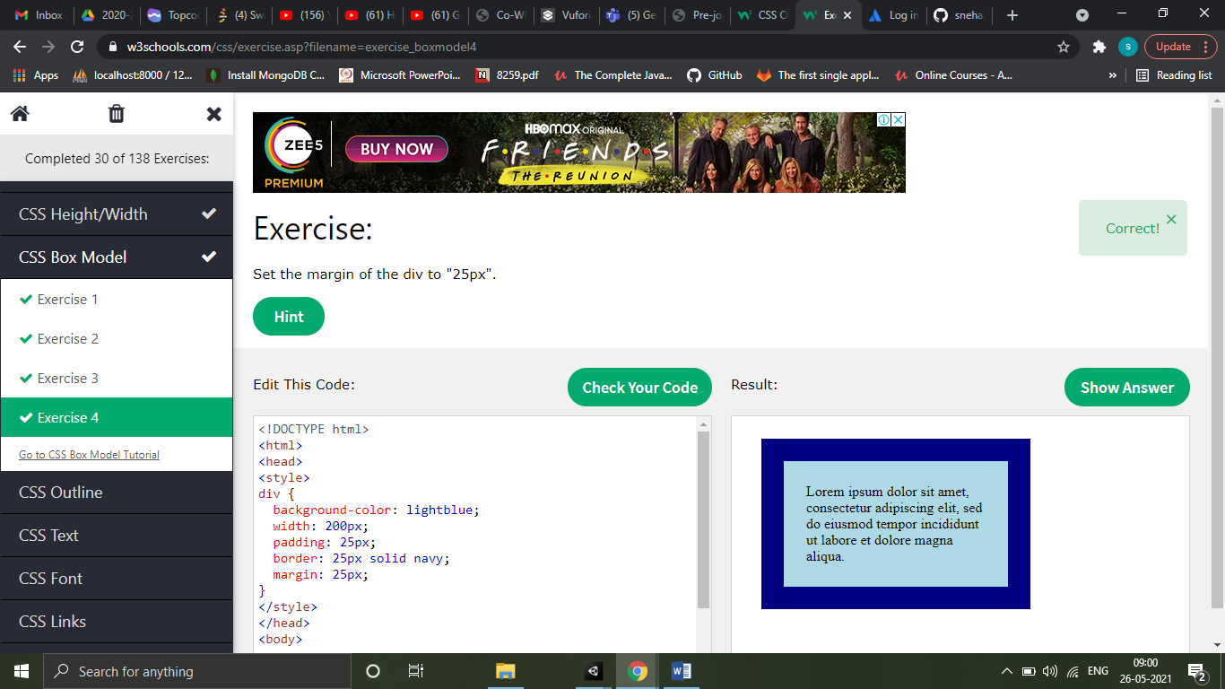

CSS Outline

CSS Outline is a line that is drawn around elements, outside the borders to make an element stand-out.

|  |  |
| --- | --- |
| **Property** | **Description** |
| [outline](https://www.w3schools.com/cssref/pr_outline.asp) | A shorthand property for setting outline-width, outline-style, and outline-color in one declaration |
| [outline-color](https://www.w3schools.com/cssref/pr_outline-color.asp) | Sets the color of an outline |
| [outline-offset](https://www.w3schools.com/cssref/css3_pr_outline-offset.asp) | Specifies the space between an outline and the edge or border of an element |
| [outline-style](https://www.w3schools.com/cssref/pr_outline-style.asp) | Sets the style of an outline |
| [outline-width](https://www.w3schools.com/cssref/pr_outline-width.asp) | Sets the width of an outline |

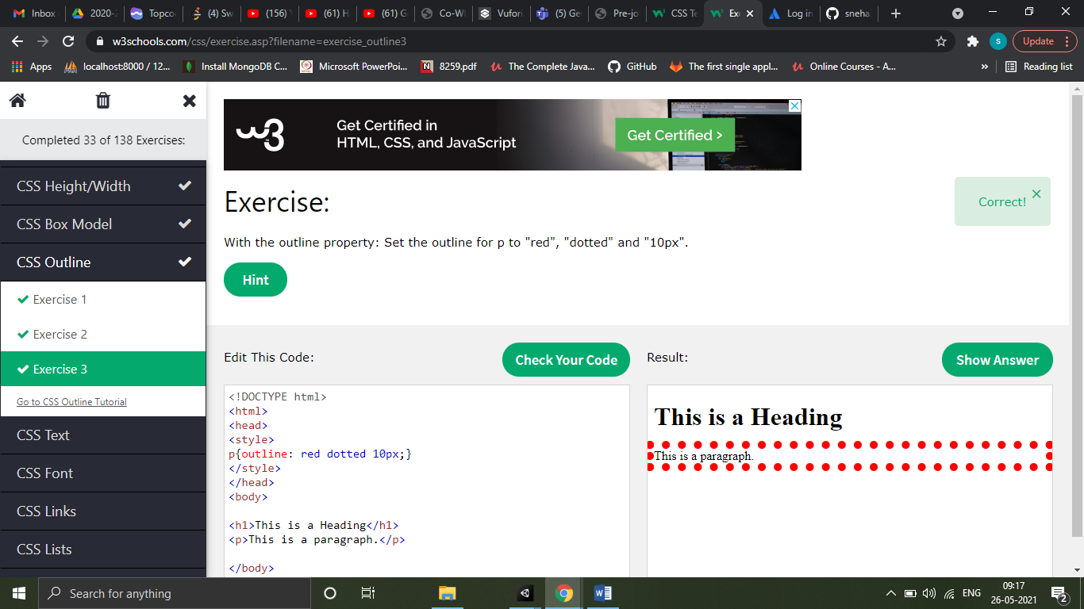

CSS Text

Text Color => color

Text alignment => text-align (center, left, right)

Text decoration => text-decoration (for underline, removing underline)

Text transform => text-transform (uppercase, lowercase, capitalize)

Text spacing => text-indent, letter-spacing, line-height, word-spacing, white-space

Text shadow => text-shadow

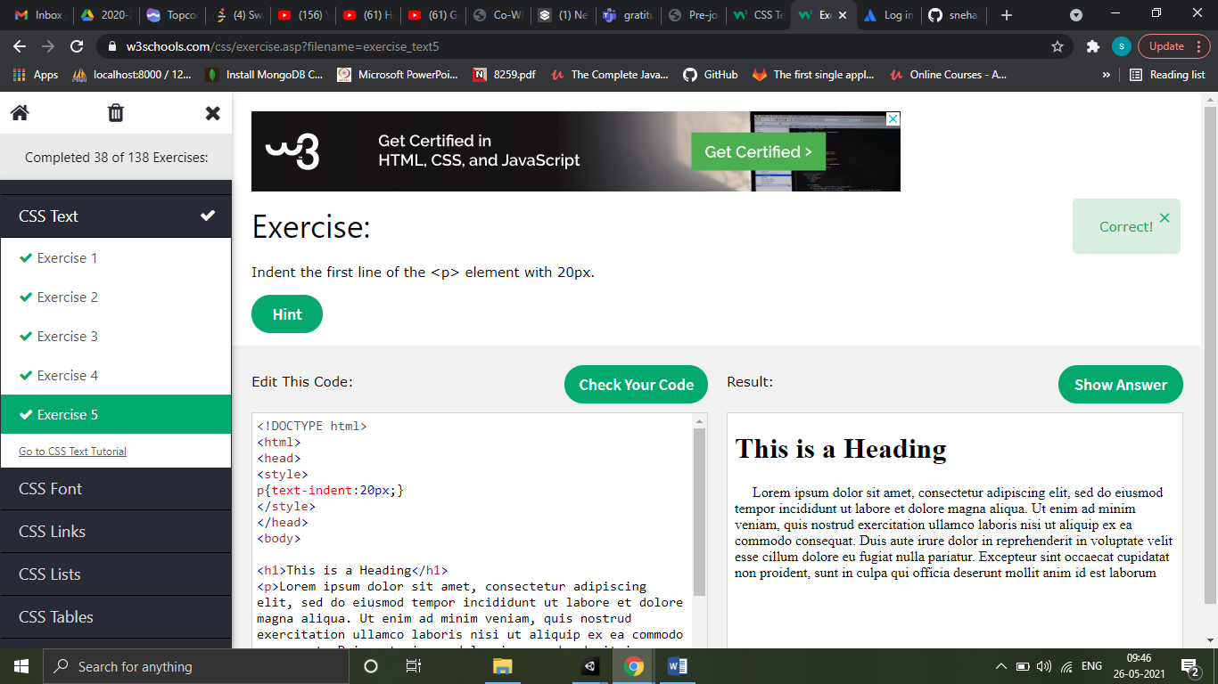

CSS Font

Font pairing rules

* Compliment
* Use font superfamilies
* Contrast is king
* Choose only one boss
* Popular google font pairings
* Georgia and verdana
* Helvetica and Garamond
* Merriweather and open sans
* Ubuntu and lora
* Abril fatface and poppins
* Cinzel and fauna one
* Fjalla one and libre Baskerville
* Space mono and muli
* Spectral and rubik
* Oswald and noto sans

|  |  |
| --- | --- |
| **Property** | **Description** |
| [font](https://www.w3schools.com/cssref/pr_font_font.asp) | Sets all the font properties in one declaration |
| [font-family](https://www.w3schools.com/cssref/pr_font_font-family.asp) | Specifies the font family for text |
| [font-size](https://www.w3schools.com/cssref/pr_font_font-size.asp) | Specifies the font size of text |
| [font-style](https://www.w3schools.com/cssref/pr_font_font-style.asp) | Specifies the font style for text |
| [font-variant](https://www.w3schools.com/cssref/pr_font_font-variant.asp) | Specifies whether or not a text should be displayed in a small-caps font |
| [font-weight](https://www.w3schools.com/cssref/pr_font_weight.asp) | Specifies the weight of a font |

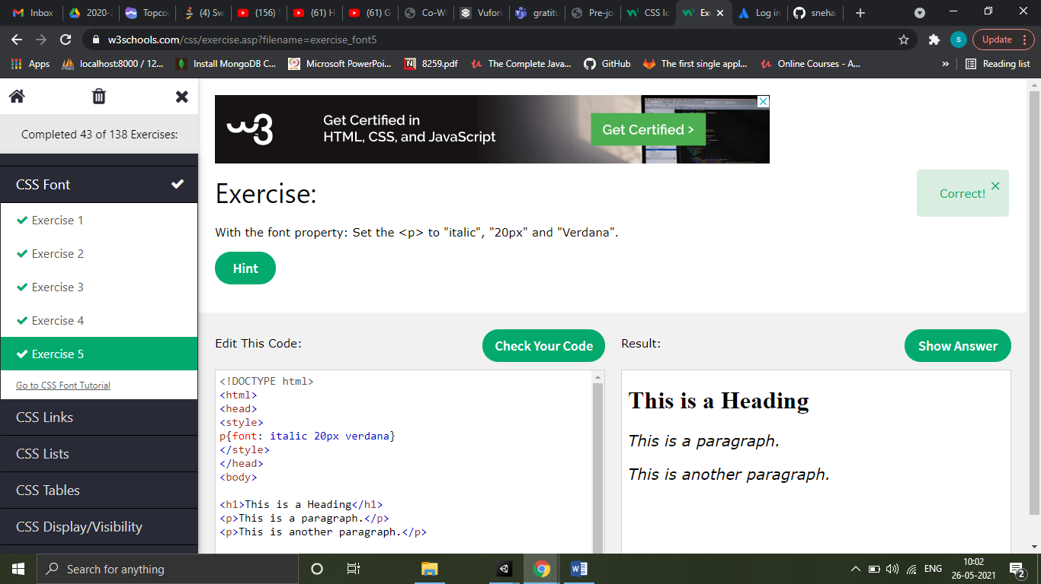

CSS Links

When setting the style for several link states, there are some order rules:

* a:hover MUST come after a:link and a:visited
* a:active MUST come after a:hover

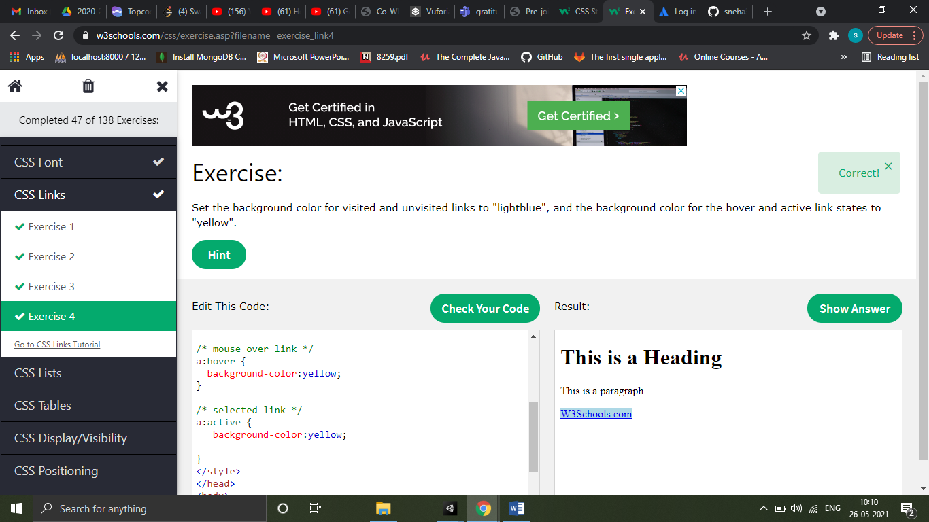

CSS Lists

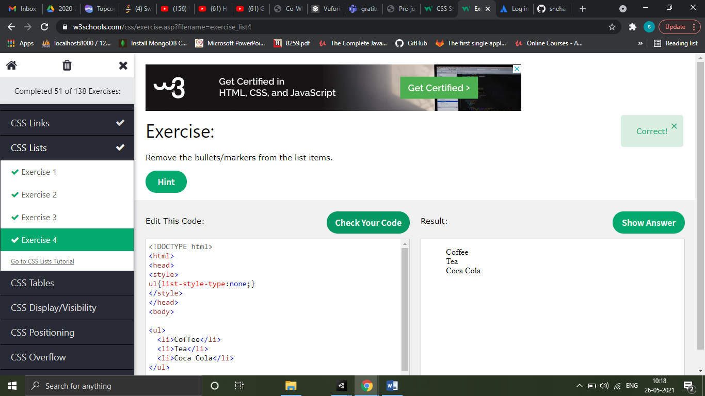

|  |  |
| --- | --- |
| **Property** | **Description** |
| [list-style](https://www.w3schools.com/cssref/pr_list-style.asp) | Sets all the properties for a list in one declaration |
| [list-style-image](https://www.w3schools.com/cssref/pr_list-style-image.asp) | Specifies an image as the list-item marker |
| [list-style-position](https://www.w3schools.com/cssref/pr_list-style-position.asp) | Specifies the position of the list-item markers (bullet points) |
| [list-style-type](https://www.w3schools.com/cssref/pr_list-style-type.asp) | Specifies the type of list-item marker |

CSS Table

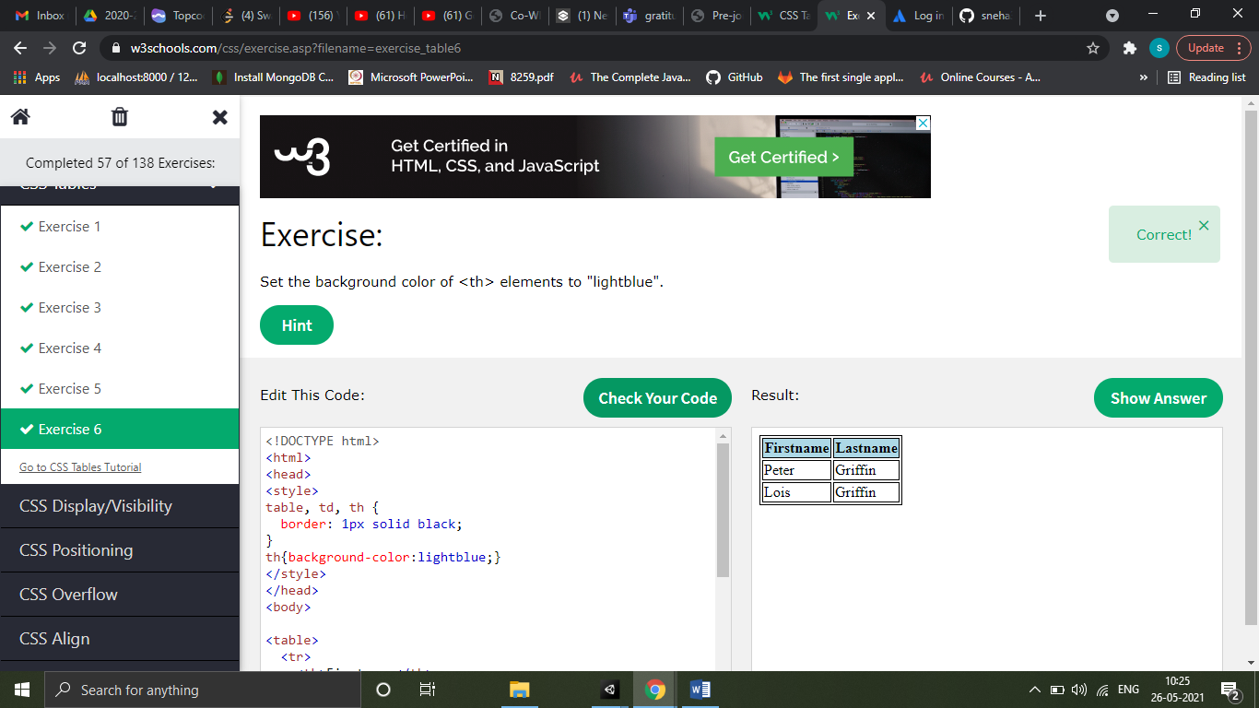

To make the table responsive add style=’overflow-x:auto;’ in your div element

|  |  |
| --- | --- |
| **Property** | **Description** |
| [border](https://www.w3schools.com/cssref/pr_border.asp) | Sets all the border properties in one declaration |
| [border-collapse](https://www.w3schools.com/cssref/pr_border-collapse.asp) | Specifies whether or not table borders should be collapsed |
| [border-spacing](https://www.w3schools.com/cssref/pr_border-spacing.asp) | Specifies the distance between the borders of adjacent cells |
| [caption-side](https://www.w3schools.com/cssref/pr_tab_caption-side.asp) | Specifies the placement of a table caption |
| [empty-cells](https://www.w3schools.com/cssref/pr_tab_empty-cells.asp) | Specifies whether or not to display borders and background on empty cells in a table |
| [table-layout](https://www.w3schools.com/cssref/pr_tab_table-layout.asp) | Sets the layout algorithm to be used for a table |

CSS Display

Example of block level elements

* <div>
* <h1> - <h6>
* <p>
* <form>
* <header>
* <footer>
* <section>

Example of inline elements

* <span>
* <a>
* <img>

|  |  |
| --- | --- |
| **Property** | **Description** |
| [display](https://www.w3schools.com/cssref/pr_class_display.asp) | Specifies how an element should be displayed |
| [visibility](https://www.w3schools.com/cssref/pr_class_visibility.asp) | Specifies whether or not an element should be visible |

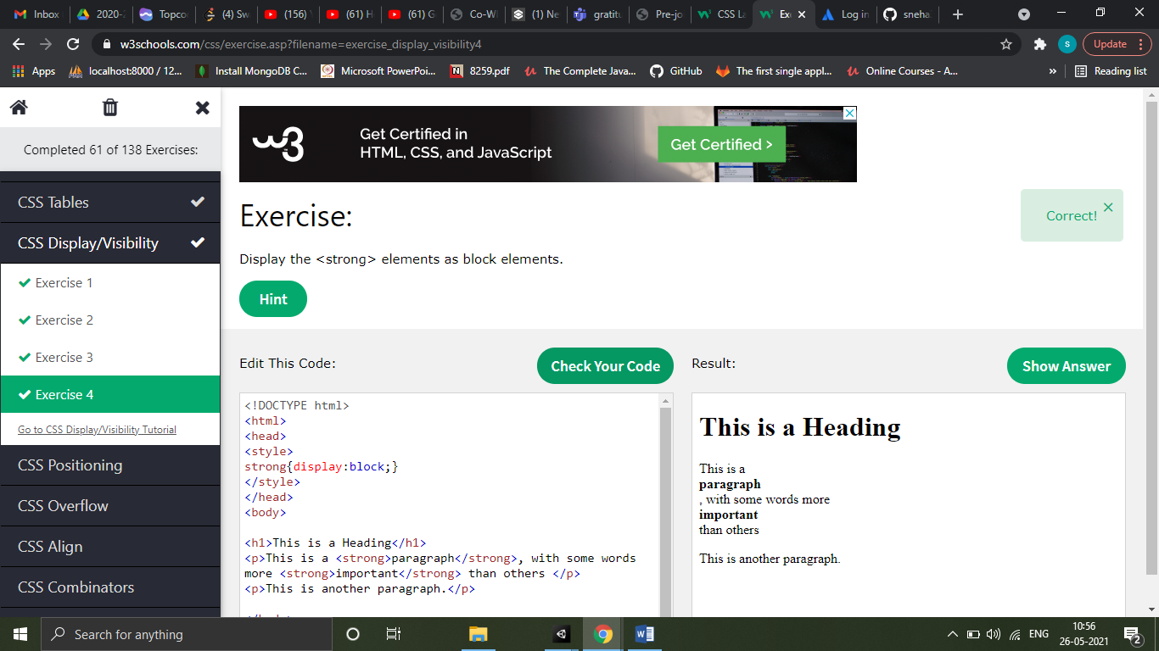

CSS Position

CSS positioning properties

|  |  |
| --- | --- |
| **Property** | **Description** |
| [bottom](https://www.w3schools.com/cssref/pr_pos_bottom.asp) | Sets the bottom margin edge for a positioned box |
| [clip](https://www.w3schools.com/cssref/pr_pos_clip.asp) | Clips an absolutely positioned element |
| [left](https://www.w3schools.com/cssref/pr_pos_left.asp) | Sets the left margin edge for a positioned box |
| [position](https://www.w3schools.com/cssref/pr_class_position.asp) | Specifies the type of positioning for an element |
| [right](https://www.w3schools.com/cssref/pr_pos_right.asp) | Sets the right margin edge for a positioned box |
| [top](https://www.w3schools.com/cssref/pr_pos_top.asp) | Sets the top margin edge for a positioned box |
| [z-index](https://www.w3schools.com/cssref/pr_pos_z-index.asp) | Sets the stack order of an element |

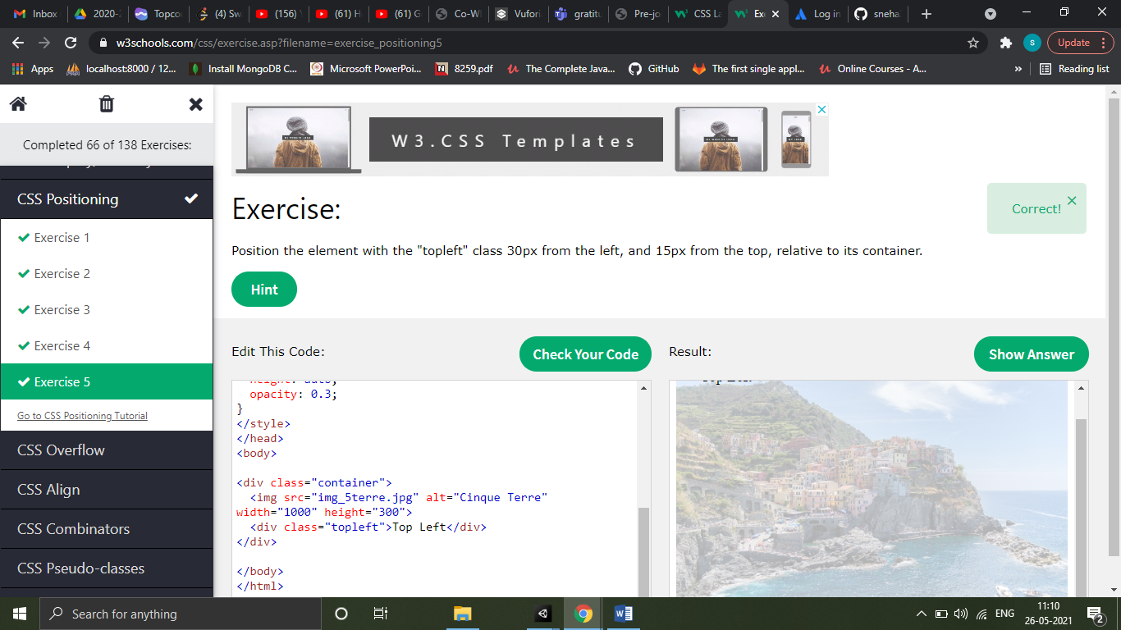

CSS Overflow

The overflow property has the following values:

* visible - Default. The overflow is not clipped. The content renders outside the element's box
* hidden - The overflow is clipped, and the rest of the content will be invisible
* scroll - The overflow is clipped, and a scrollbar is added to see the rest of the content
* auto - Similar to scroll, but it adds scrollbars only when necessary

The overflow property only works for block elements with a specified height.

By default, the overflow is visible, meaning that it is not clipped and it renders outside the element's box

overflow-x specifies what to do with the left/right edges of the content.  
overflow-y specifies what to do with the top/bottom edges of the content.

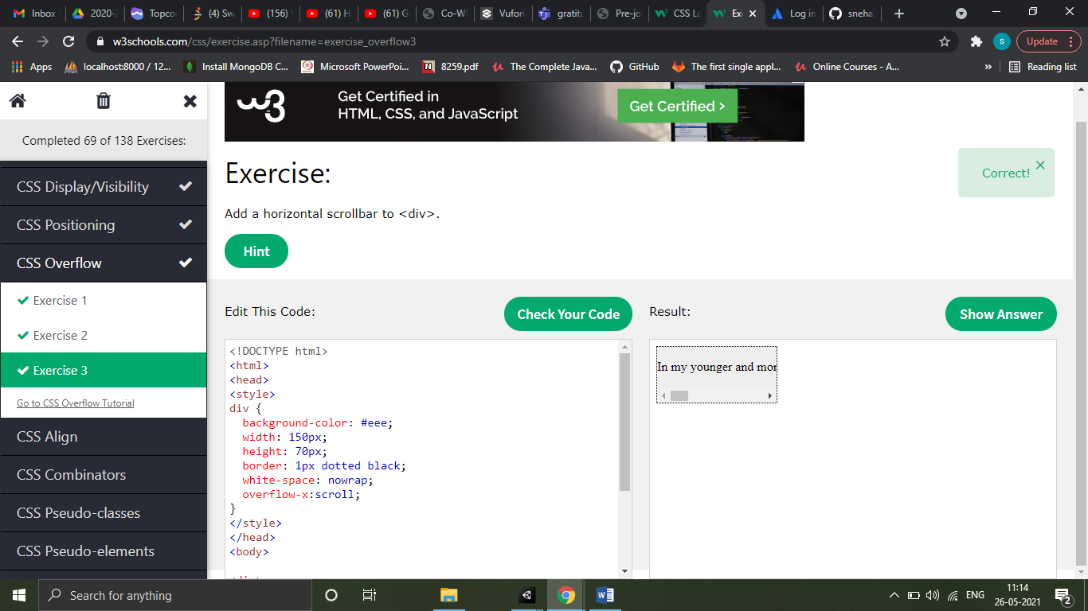

CSS Float

The float property is used for positioning and formatting content e.g. let an image float left to the text in a container.

The float property can have one of the following values:

* left - The element floats to the left of its container
* right - The element floats to the right of its container
* none - The element does not float (will be displayed just where it occurs in the text). This is default
* inherit - The element inherits the float value of its parent

In its simplest use, the float property can be used to wrap text around images.

The clear property specifies what elements can float beside the cleared element and on which side.

The clear property can have one of the following values:

* none - Allows floating elements on both sides. This is default
* left - No floating elements allowed on the left side
* right- No floating elements allowed on the right side
* both - No floating elements allowed on either the left or the right side
* inherit - The element inherits the clear value of its parent

The most common way to use the clear property is after you have used a float property on an element.

You can easily create three floating boxes side by side. However, when you add something that enlarges the width of each box (e.g. padding or borders), the box will break. The box-sizing property allows us to include the padding and border in the box's total width (and height), making sure that the padding stays inside of the box and that it does not break.

Use flexbox to arrange boxes of equal height side by side.

|  |  |
| --- | --- |
| **Property** | **Description** |
| [box-sizing](https://www.w3schools.com/cssref/css3_pr_box-sizing.asp) | Defines how the width and height of an element are calculated: should they include padding and borders, or not |
| [clear](https://www.w3schools.com/cssref/pr_class_clear.asp) | Specifies what elements can float beside the cleared element and on which side |
| [float](https://www.w3schools.com/cssref/pr_class_float.asp) | Specifies how an element should float |
| [overflow](https://www.w3schools.com/cssref/pr_pos_overflow.asp) | Specifies what happens if content overflows an element's box |
| [overflow-x](https://www.w3schools.com/cssref/css3_pr_overflow-x.asp) | Specifies what to do with the left/right edges of the content if it overflows the element's content area |
| [overflow-y](https://www.w3schools.com/cssref/css3_pr_overflow-y.asp) | Specifies what to do with the top/bottom edges of the content if it overflows the element's content area |

The display:inline-block; value

Compared to display: inline, the major difference is that display: inline-block allows to set a width and height on the element.

Also, with display: inline-block, the top and bottom margins/paddings are respected, but with display: inline they are not.

Compared to display: block, the major difference is that display: inline-block does not add a line-break after the element, so the element can sit next to other elements.

CSS Align

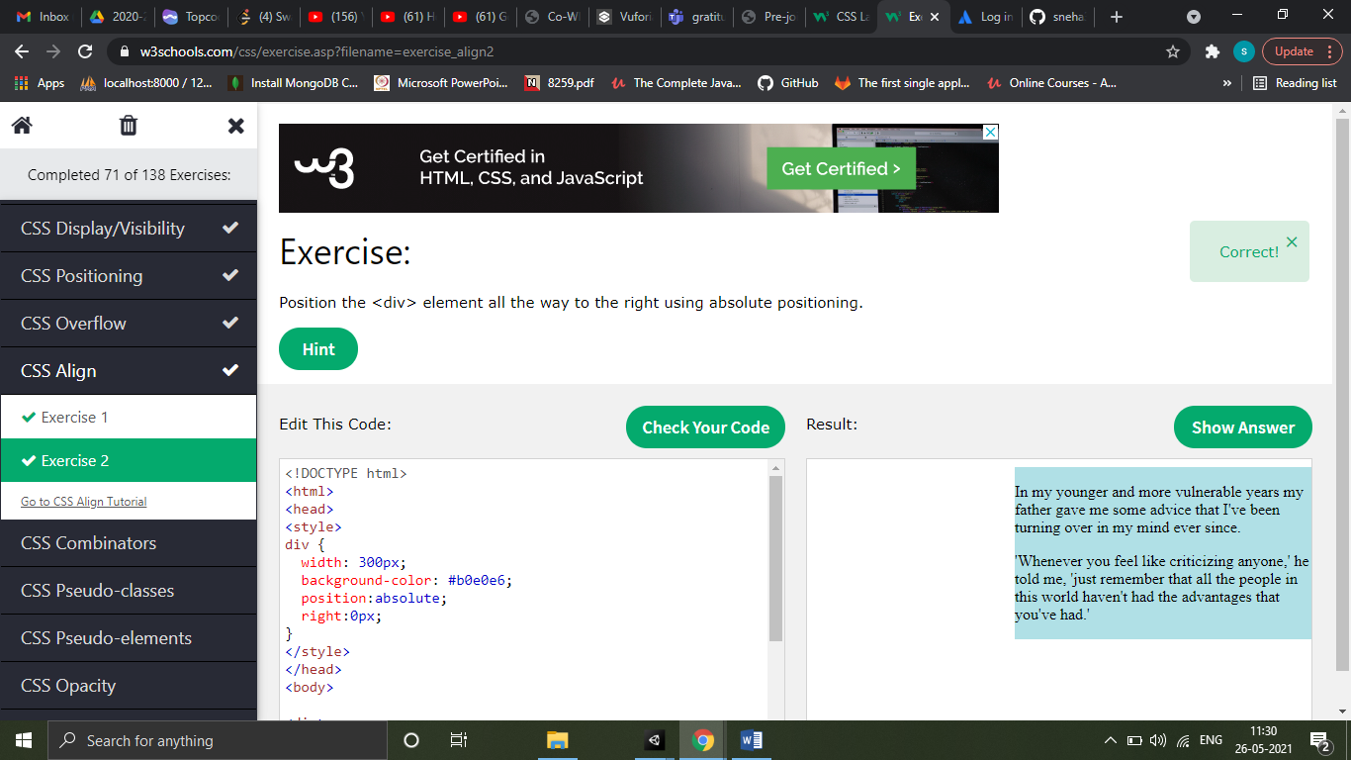

CSS Combinators

A combinator is something that explains the relationship between selectors

There are four different combinators in CSS:

* descendant selector (space)
* child selector (>)
* adjacent sibling selector (+)
* general sibling selector (~)

|  |  |  |
| --- | --- | --- |
| **Selector** | **Example** | **Example description** |
| [*element* *element*](https://www.w3schools.com/cssref/sel_element_element.asp) | div p | Selects all <p> elements inside <div> elements |
| [*element*>*element*](https://www.w3schools.com/cssref/sel_element_gt.asp) | div > p | Selects all <p> elements where the parent is a <div> element |
| [*element*+*element*](https://www.w3schools.com/cssref/sel_element_pluss.asp) | div + p | Selects the first <p> element that are placed immediately after <div> elements |
| [*element1*~*element2*](https://www.w3schools.com/cssref/sel_gen_sibling.asp) | p ~ ul | Selects every <ul> element that are preceded by a <p> element |

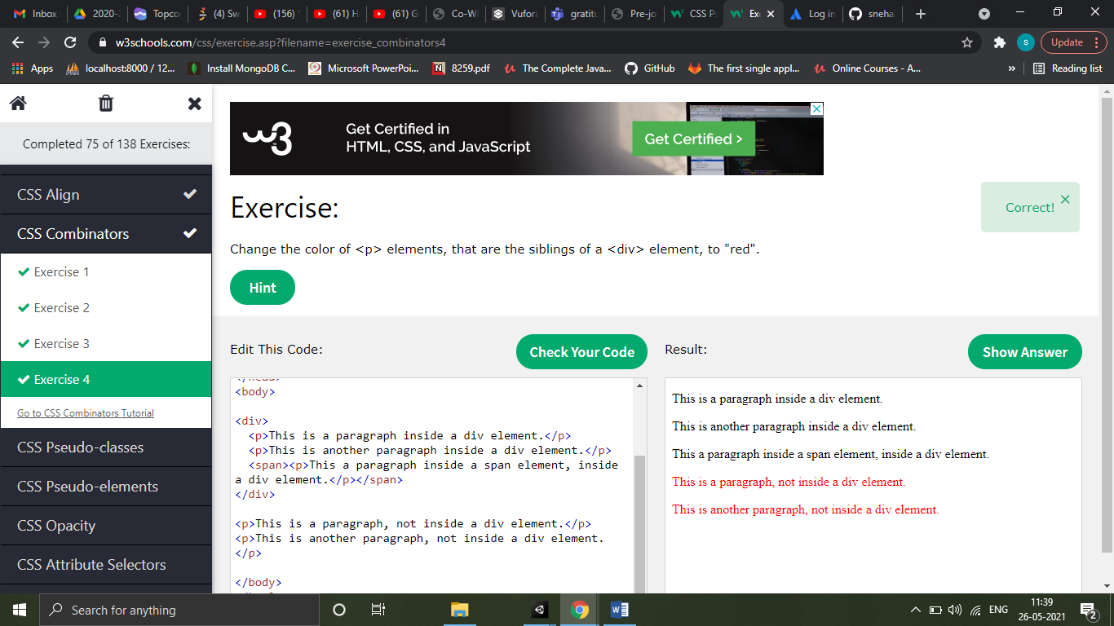

CSS Pseudo class

A pseudo-class is used to define a special state of an element.

For example, it can be used to:

* Style an element when a user mouses over it
* Style visited and unvisited links differently
* Style an element when it gets focus
* The syntax of pseudo-classes:

selector:pseudo-class {  
  property: value;  
}

Pseudo class names are not case sensitive

The :first-child pseudo-class matches a specified element that is the first child of another element.

The :lang pseudo-class allows you to define special rules for different languages.

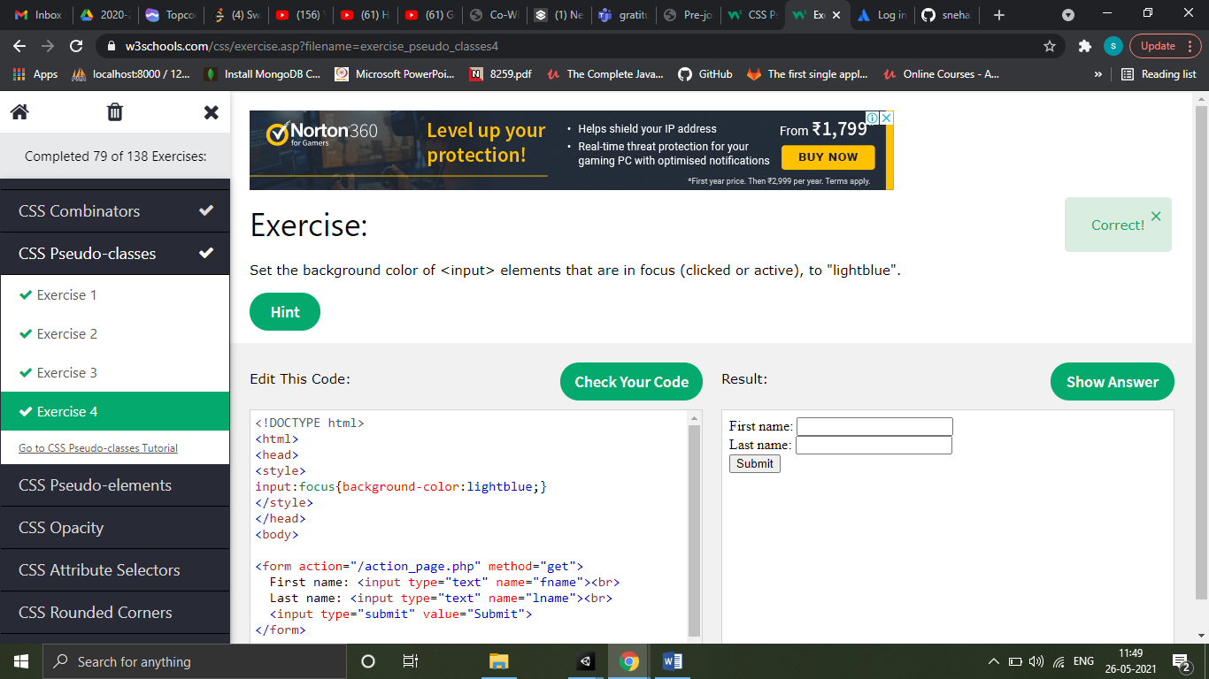

CSS Pseudo elements

A CSS pseudo-element is used to style specified parts of an element.

For example, it can be used to:

* Style the first letter, or line, of an element
* Insert content before, or after, the content of an element
* The syntax of pseudo-elements:

selector::pseudo-element {  
  property: value;  
}

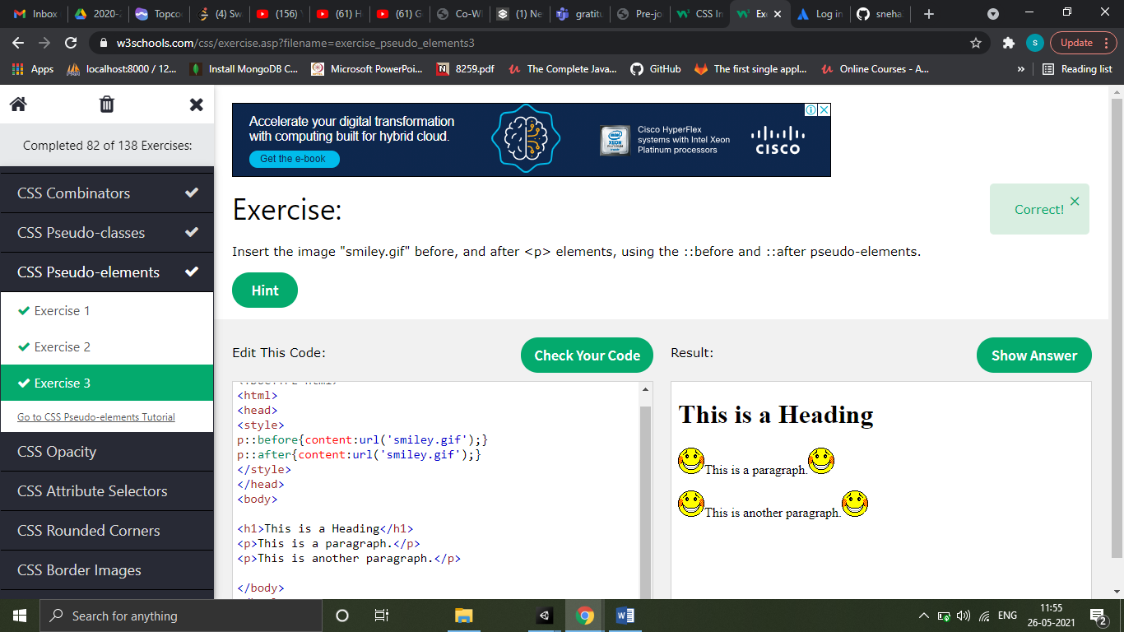

CSS Opacity

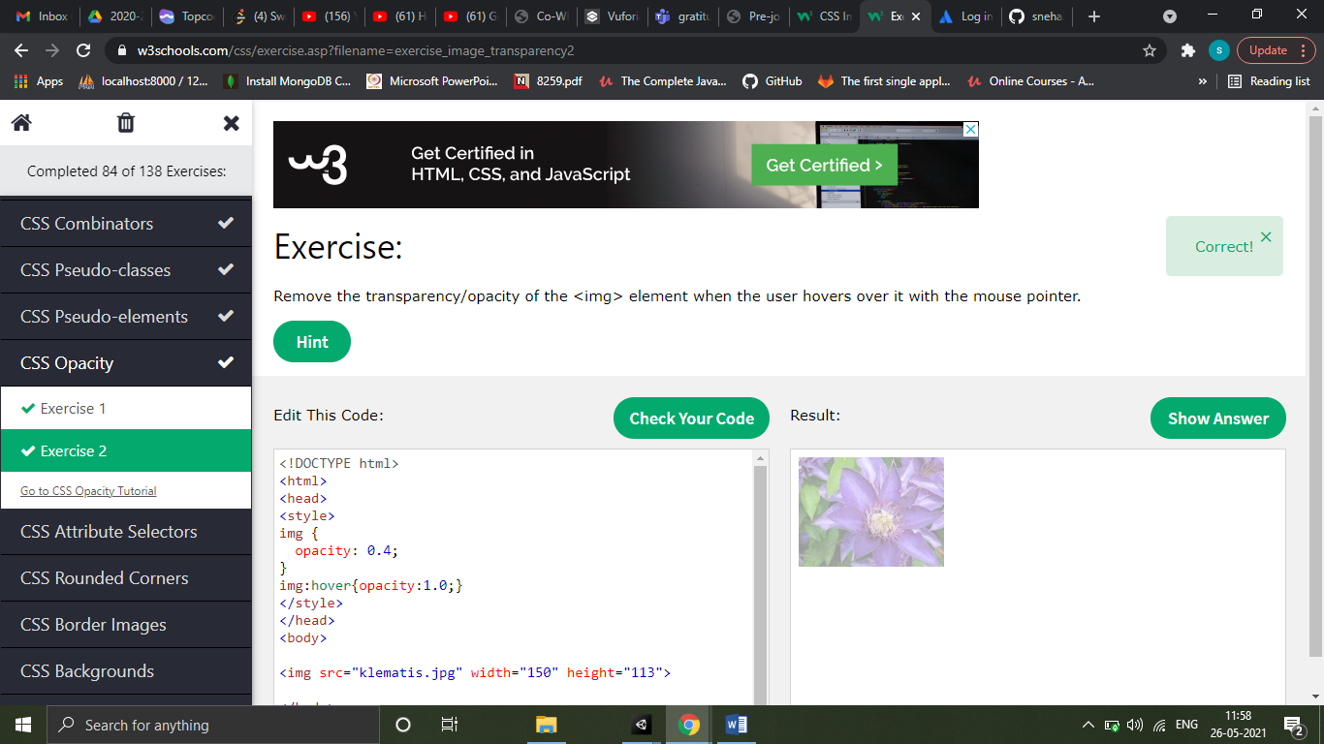

CSS Attribute selectors

The [attribute] selector is used to select elements with a specified attribute.

The following example selects all <a> elements with a target attribute:

Example -

a[target] {  
  background-color: yellow;  
}

The [attribute~="value"] selector is used to select elements with an attribute value containing a specified word.

The [attribute="value"] selector is used to select elements with a specified attribute and value.

The [attribute|="value"] selector is used to select elements with the specified attribute starting with the specified value.

The [attribute^="value"] selector is used to select elements whose attribute value begins with a specified value.

The [attribute$="value"] selector is used to select elements whose attribute value ends with a specified value.

The [attribute*="value"] selector is used to select elements whose attribute value contains a specified value.

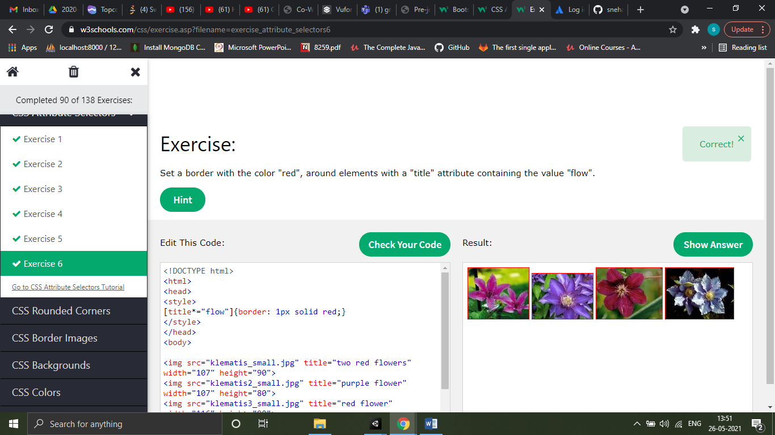

CSS Counter

CSS counters are like "variables". The variable values can be incremented by CSS rules (which will track how many times they are used).

To work with CSS counters we will use the following properties:

* counter-reset - Creates or resets a counter
* counter-increment - Increments a counter value
* content - Inserts generated content
* counter() or counters() function - Adds the value of a counter to an element

CSS Website Layout

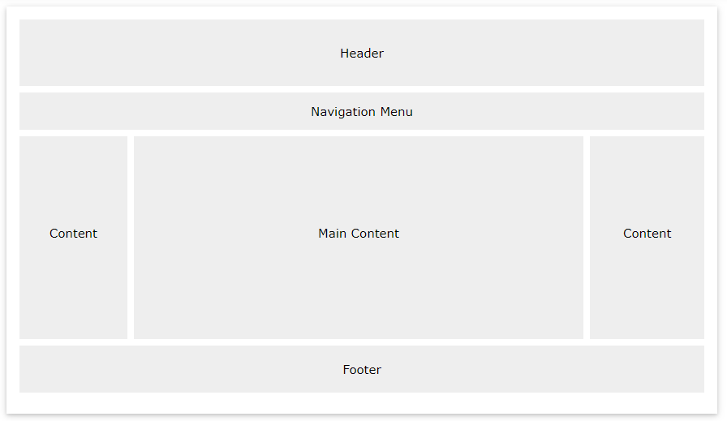

CSS !important

The !important rule in CSS is used to add more importance to a property/value than normal.

In fact, if you use the !important rule, it will override ALL previous styling rules for that specific property on that element!

CSS Rounded corners

|  |  |
| --- | --- |
| **Property** | **Description** |
| [border-radius](https://www.w3schools.com/cssref/css3_pr_border-radius.asp) | A shorthand property for setting all the four border-*-*-radius properties |
| [border-top-left-radius](https://www.w3schools.com/cssref/css3_pr_border-top-left-radius.asp) | Defines the shape of the border of the top-left corner |
| [border-top-right-radius](https://www.w3schools.com/cssref/css3_pr_border-top-right-radius.asp) | Defines the shape of the border of the top-right corner |
| [border-bottom-right-radius](https://www.w3schools.com/cssref/css3_pr_border-bottom-right-radius.asp) | Defines the shape of the border of the bottom-right corner |
| [border-bottom-left-radius](https://www.w3schools.com/cssref/css3_pr_border-bottom-left-radius.asp) | Defines the shape of the border of the bottom-left corner |

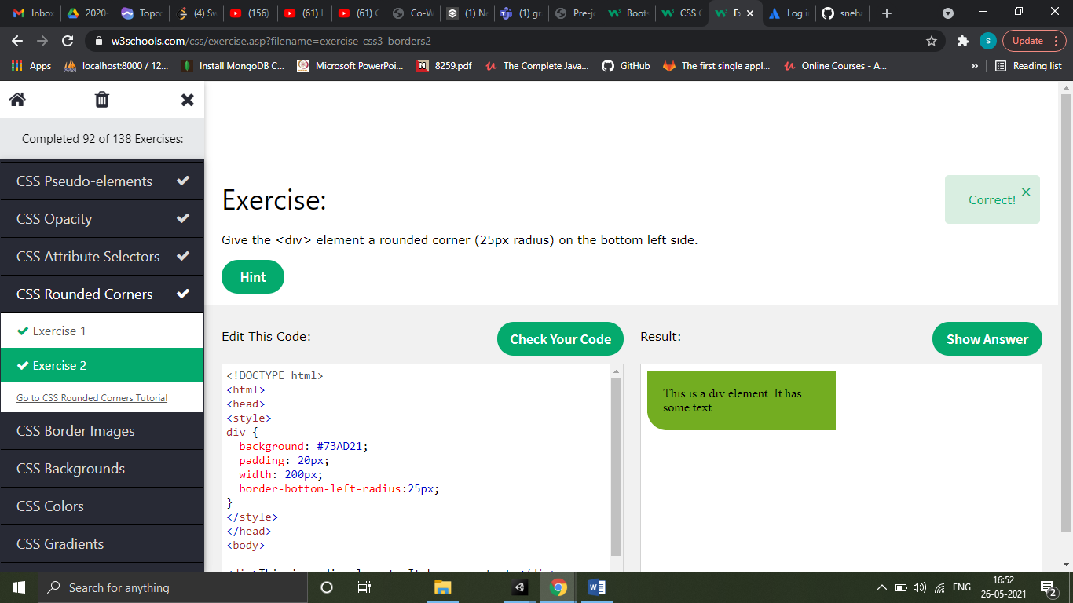

CSS Border Image

|  |  |
| --- | --- |
| **Property** | **Description** |
| [border-image](https://www.w3schools.com/cssref/css3_pr_border-image.asp) | A shorthand property for setting all the border-image-* properties |
| [border-image-source](https://www.w3schools.com/cssref/css3_pr_border-image-source.asp) | Specifies the path to the image to be used as a border |
| [border-image-slice](https://www.w3schools.com/cssref/css3_pr_border-image-slice.asp) | Specifies how to slice the border image |
| [border-image-width](https://www.w3schools.com/cssref/css3_pr_border-image-width.asp) | Specifies the widths of the border image |
| [border-image-outset](https://www.w3schools.com/cssref/css3_pr_border-image-outset.asp) | Specifies the amount by which the border image area extends beyond the border box |
| [border-image-repeat](https://www.w3schools.com/cssref/css3_pr_border-image-repeat.asp) | Specifies whether the border image should be repeated, rounded or stretched |

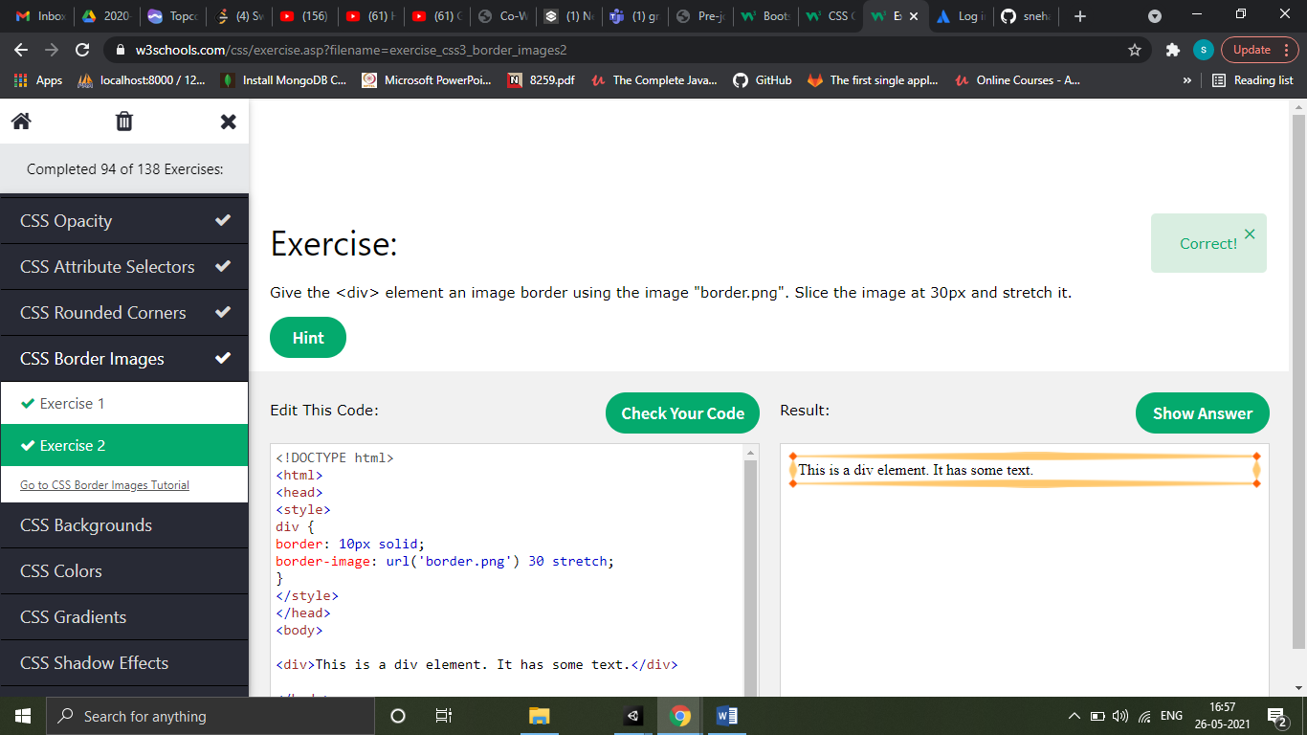

CSS Backgrounds

|  |  |
| --- | --- |
| **Property** | **Description** |
| [background](https://www.w3schools.com/cssref/css3_pr_background.asp) | A shorthand property for setting all the background properties in one declaration |
| [background-clip](https://www.w3schools.com/cssref/css3_pr_background-clip.asp) | Specifies the painting area of the background |
| [background-image](https://www.w3schools.com/cssref/pr_background-image.asp) | Specifies one or more background images for an element |
| [background-origin](https://www.w3schools.com/cssref/css3_pr_background-origin.asp) | Specifies where the background image(s) is/are positioned |
| [background-size](https://www.w3schools.com/cssref/css3_pr_background-size.asp) | Specifies the size of the background image(s) |

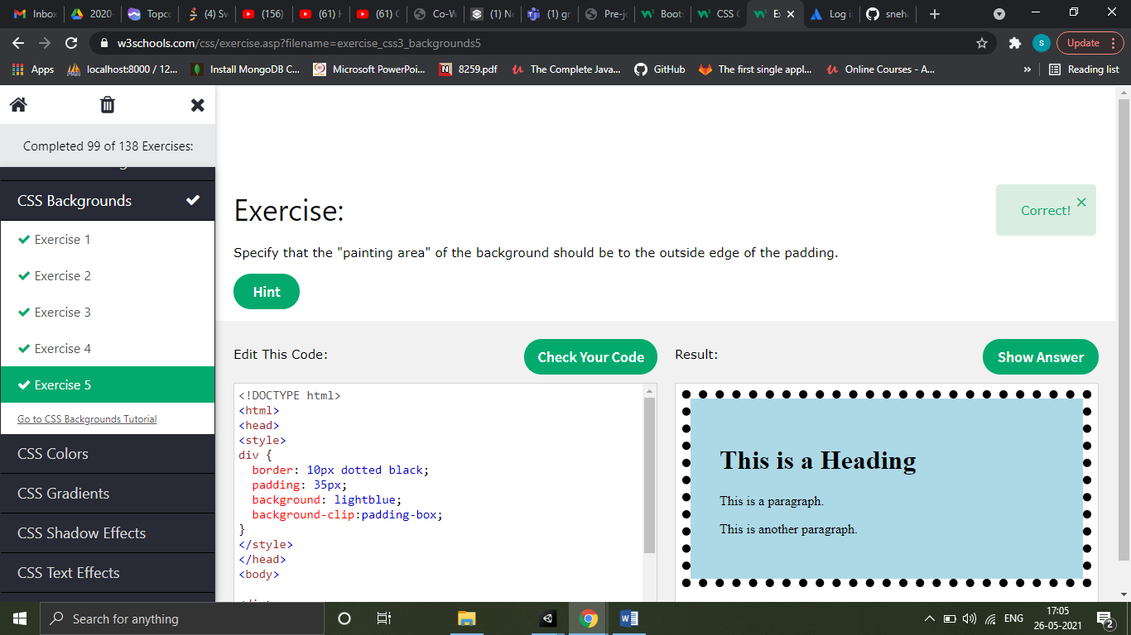

CSS Color

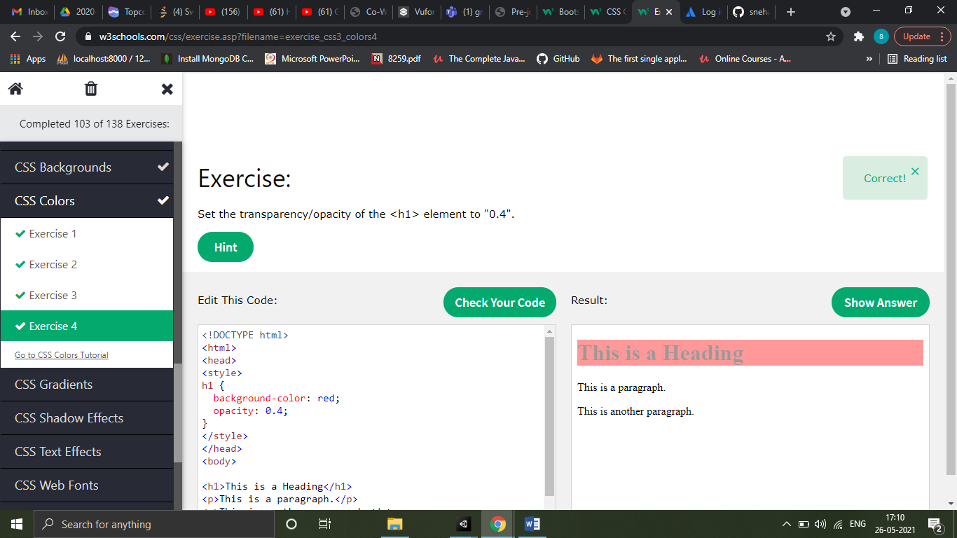

The transparent keyword is used to make a color transparent. This is often used to make a transparent background color for an element.

The currentcolor keyword is like a variable that holds the current value of the color property of an element.

This keyword can be useful if you want a specific color to be consistent in an element or a page.

The inherit keyword specifies that a property should inherit its value from its parent element.

The inherit keyword can be used for any CSS property, and on any HTML element.

CSS Gradients

Linear gradient - background-image: linear-gradient(direction, color-stop1, color-stop2, ...);

background-image: linear-gradient(*angle*, *color-stop1*, *color-stop2*);

Radial gradient - background-image: radial-gradient(*shape size*at*position, start-color, ..., last-color*);

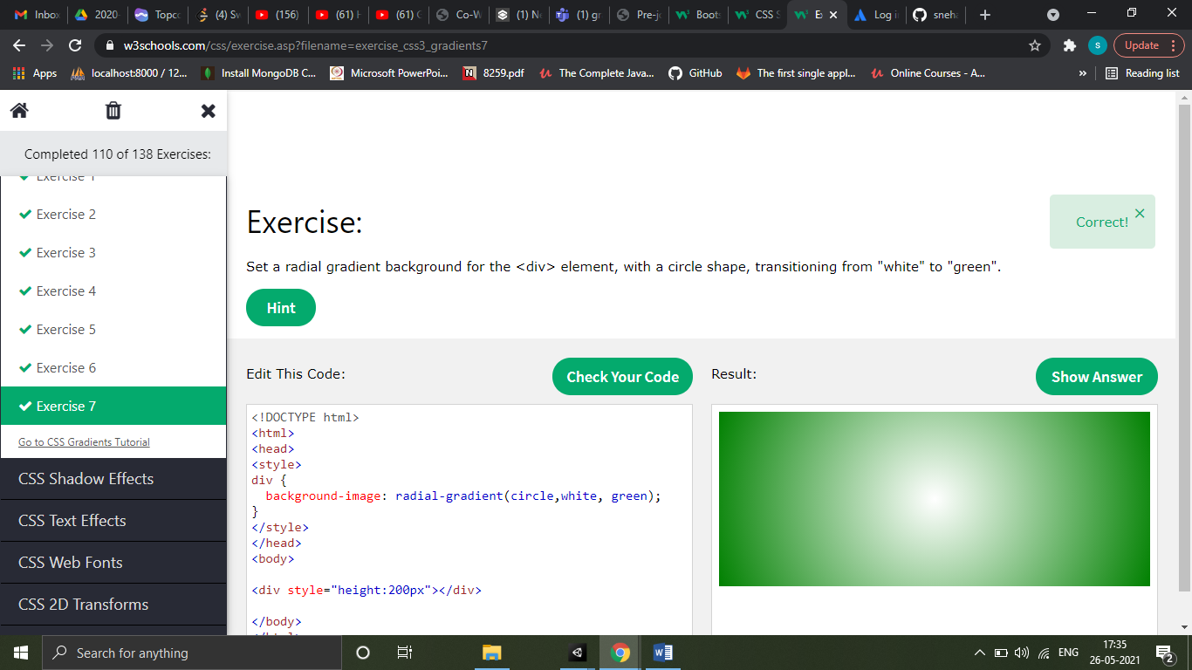

CSS Shadows

|  |  |
| --- | --- |
| **Property** | **Description** |
| [box-shadow](https://www.w3schools.com/cssref/css3_pr_box-shadow.asp) | Adds one or more shadows to an element |
| [text-shadow](https://www.w3schools.com/cssref/css3_pr_text-shadow.asp) | Adds one or more shadows to a text |

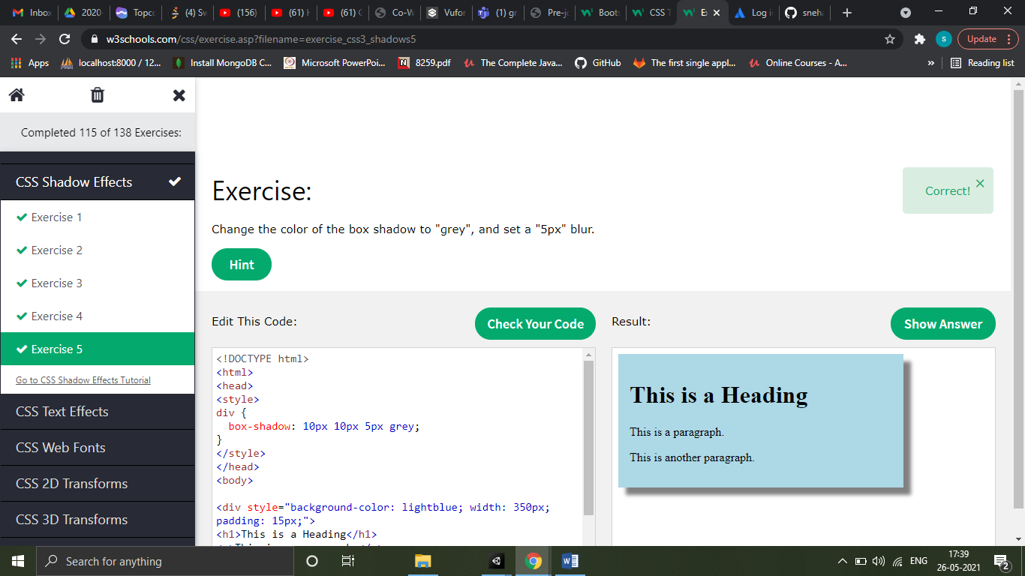

CSS Text effects

The CSS text-overflow property specifies how overflowed content that is not displayed should be signaled to the user.

The word-wrap property allows you to force the text to wrap - even if it means splitting it in the middle of a word

The CSS word-break property specifies line breaking rules.

The CSS writing-mode property specifies whether lines of text are laid out horizontally or vertically.

|  |  |
| --- | --- |
| **Property** | **Description** |
| [text-align-last](https://www.w3schools.com/cssref/css3_pr_text-align-last.asp) | Specifies how to align the last line of a text |
| [text-justify](https://www.w3schools.com/cssref/css3_pr_text-justify.asp) | Specifies how justified text should be aligned and spaced |
| [text-overflow](https://www.w3schools.com/cssref/css3_pr_text-overflow.asp) | Specifies how overflowed content that is not displayed should be signaled to the user |
| [word-break](https://www.w3schools.com/cssref/css3_pr_word-break.asp) | Specifies line breaking rules for non-CJK scripts |
| [word-wrap](https://www.w3schools.com/cssref/css3_pr_word-wrap.asp) | Allows long words to be able to be broken and wrap onto the next line |
| [writing-mode](https://www.w3schools.com/cssref/css3_pr_writing-mode.asp) | Specifies whether lines of text are laid out horizontally or vertically |

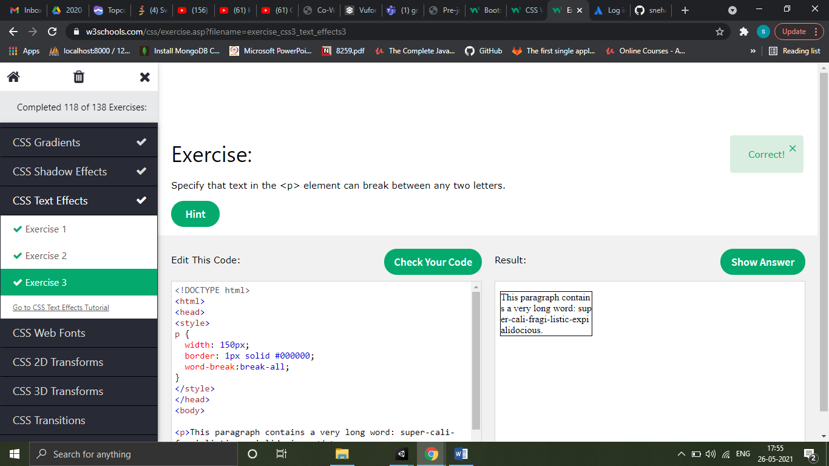

CSS Web font

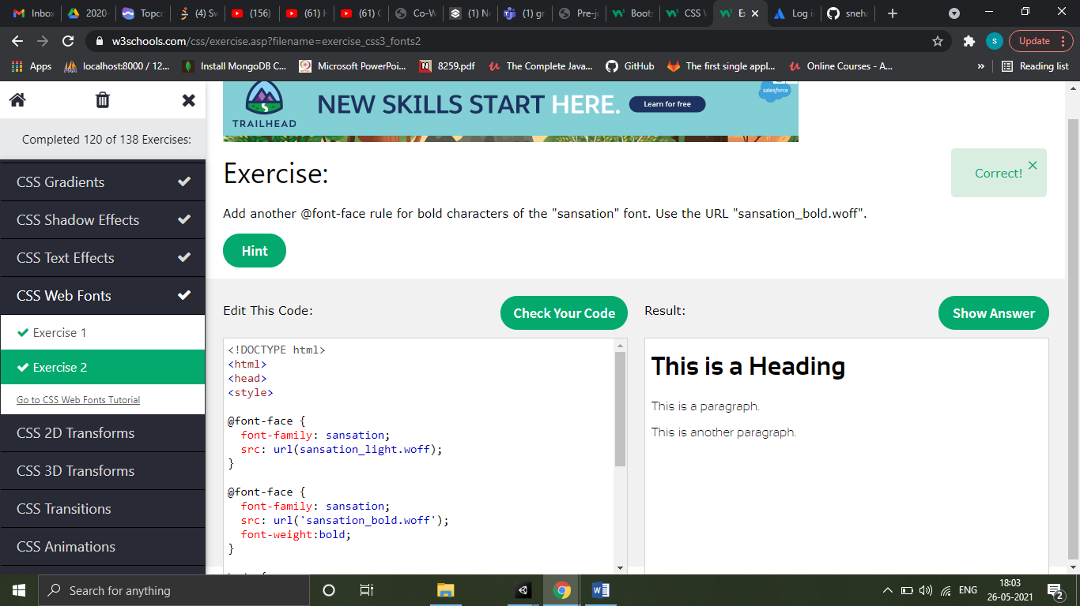

CSS 2D transform

CSS transforms allow you to move, rotate, scale, and skew elements.

With the CSS transform property you can use the following 2D transformation methods:

* translate()
* rotate()
* scaleX()
* scaleY()
* scale()
* skewX()
* skewY()
* skew()
* matrix()

matrix(scaleX(),skewY(),skewX(),scaleY(),translateX(),translateY())

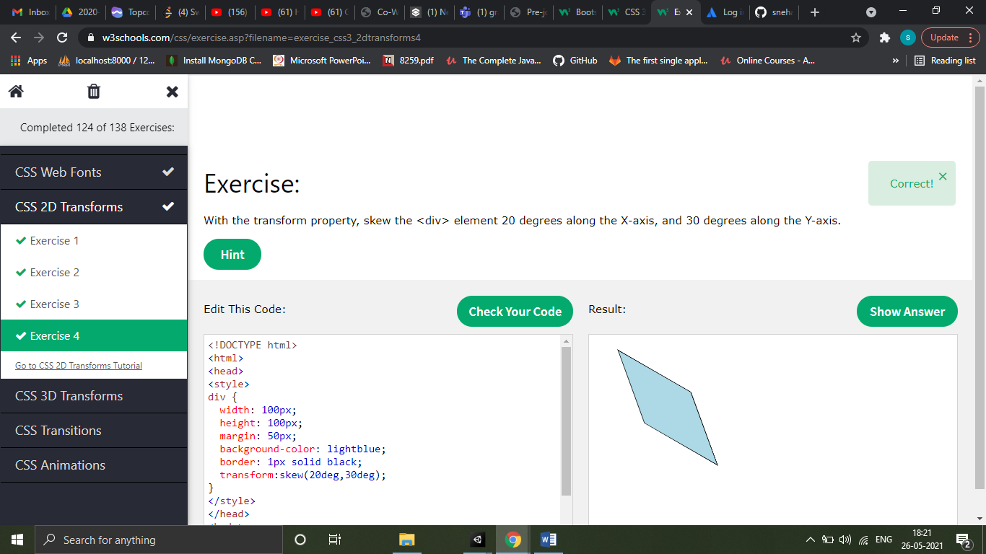

CSS 3D transform

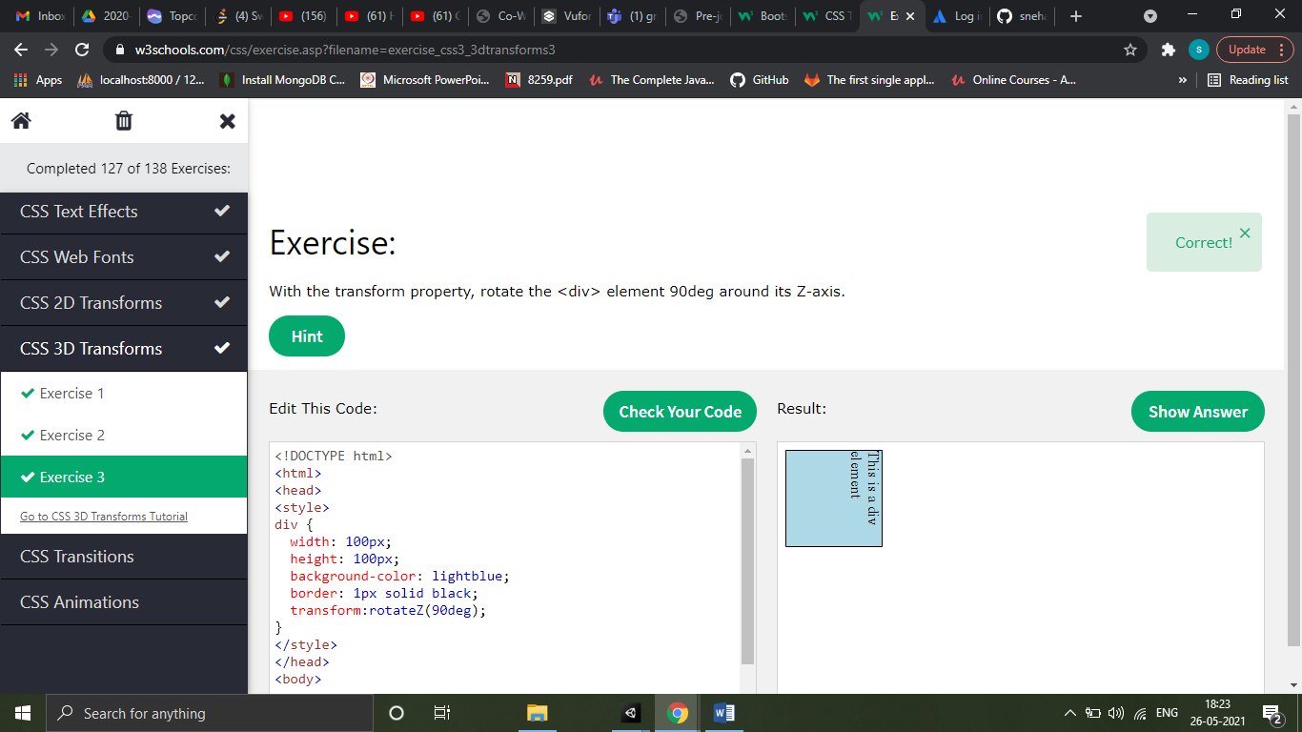

CSS Transitions

CSS transitions allows you to change property values smoothly, over a given duration.

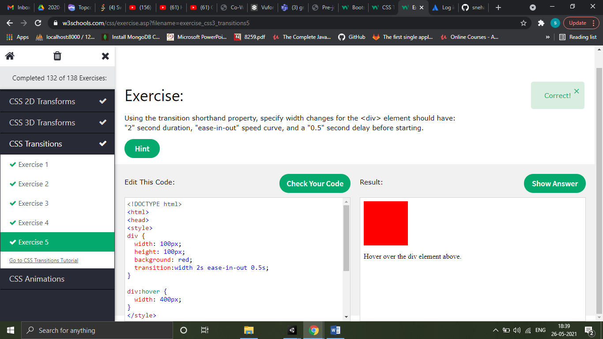

CSS Animations

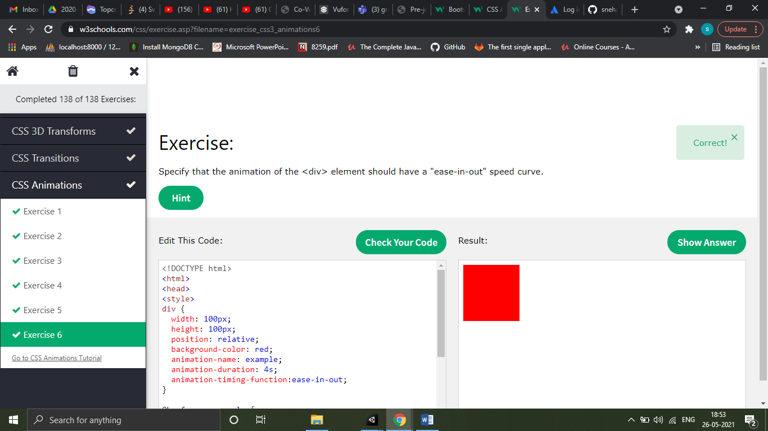

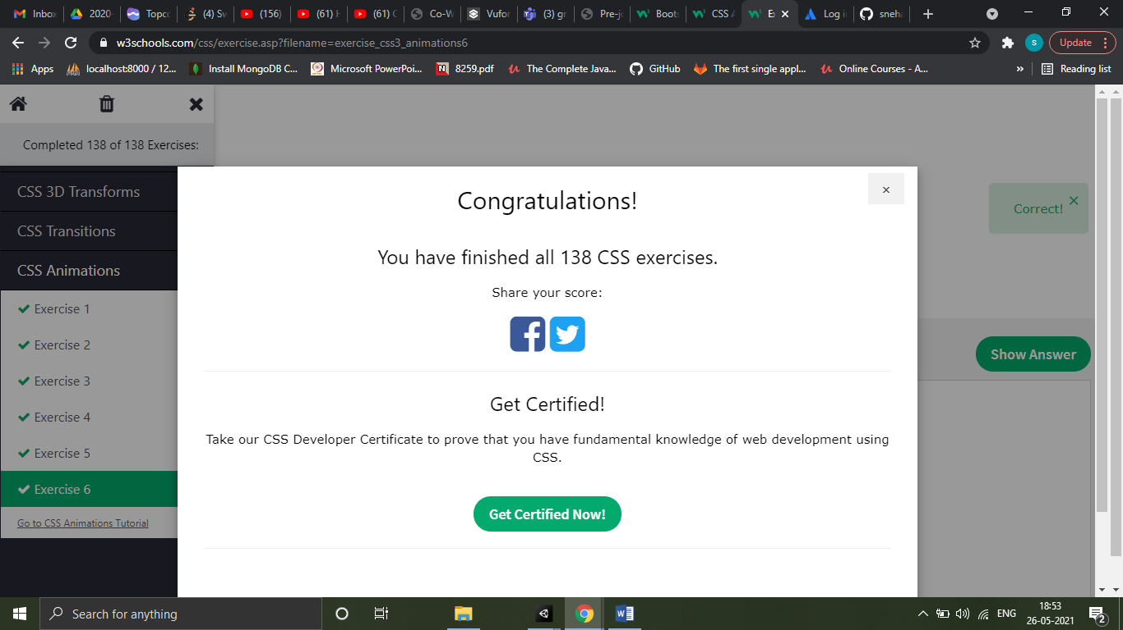

QUIZ

